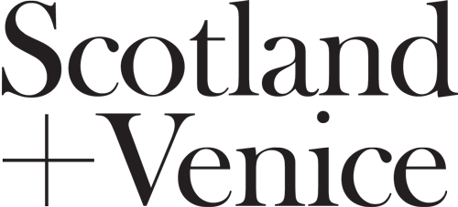

Please complete your proposal by using the headings provided in this template and return to amanda.catto@creativescotland.com by 5pm on Friday May 2018. We are looking for proposals that provide a level of detail that will help us to determine how well the project would meet the objectives that we have set out in the Open Call. As a guide we would expect a submission that is up to 6 pages of A4, plus an indicative budget.

- Please tell us your name, address, email address and telephone number/s:

- Please tell us about the project that you wish to deliver for Scotland + Venice 2019, including which artist or artists you intend to work with and if you have any thoughts on a preferred location or venue.

- Please tell us why you think this project would be particularly appropriate/relevant for Scotland + Venice 2019, how it meets the brief that we have outlined and what you hope to achieve.

- Please tell us what preparatory work you have done in developing this proposal and the extent to which you have involved the artist/s in the plans to date (please note that we would expect you to have agreed with the artist/s involved that they would be interested/available to work with you on Scotland + Venice 2019).

- Please tell us who will be involved in delivering the project, including any collaborations or partnerships that you aim to establish.

- Please tell us how you would hope to manage the staffing/invigilation of the project and your thoughts on building the learning/professional development programmes that we have established with the universities/colleges.

- Please provide us with CVs and any supporting material that helps to demonstrate the experience of the key people involved, including the artist/s. If you would be seeking to recruit people to manage specific aspects of project delivery then please advise how you would aim to do this.

- Please provide us with an initial budget for the project (please note that we have provided an outline budget to help you anticipate/accommodate the core costs that need to be given consideration)

If you require any advice on making a proposal please contact amanda.catto@creativescotland.com

Thank you!

